West African Kingdoms
DIRECTIONS: You and partner(s) will be reading about the 4 major West African Kingdoms. As you read highlight and make note important cities, cultural characteristics, government characteristics, and economic characteristics. You will then be given a list of facts and characteristics that you will need to match the West African Kingdom that they go with.
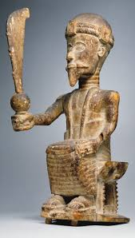  GHANA | 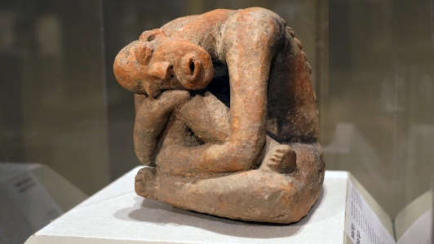  MALI | 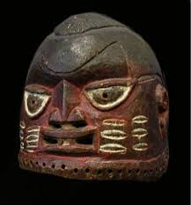  SONGHAI | 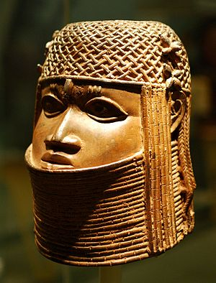  BENIN

